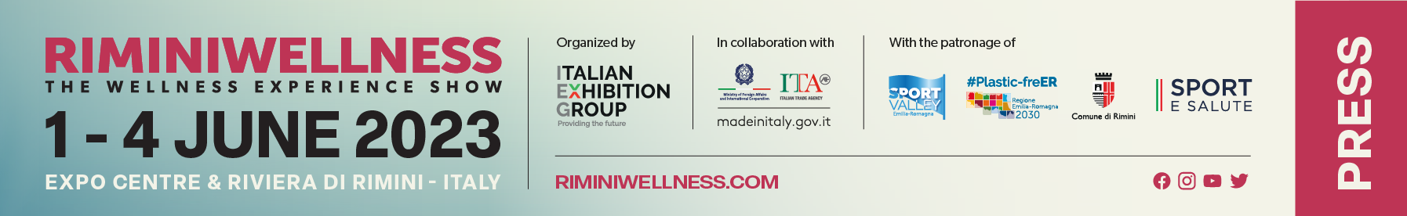

press release

IEG: RIMINIWELLNESS KICKS OFF TOMORROW.
FOR 4 DAYS RIMINI, CAPITAL OF TOURISM,
WILL ALSO BE THE EUROPEAN CAPITAL OF FITNESS AND WELLNESS

- The States General of Wellness on the opening day with Vito Cozzoli, President of Sport e Salute. Lorenzo Angeloni, Director General for Country System Promotion at the Ministry of Foreign Affairs and International Cooperation in attendance at the opening
- Conferences, masterclasses, meetings, trends, but also lots of entertainment and fun
- RiminiWellness Off debuts with over 240 events scheduled to enliven the city of Rimini

Rimini, 31st May 2023 – Ever fuller and more international, always more in shape. From tomorrow to 4th June, RiminiWellness will turn Rimini into the European capital of wellness thanks to a programme able to involve all the industry’s major national and international players, stakeholders and professionals as well as countless fitness and wellness enthusiasts

The incredible number of activities, events, conferences, masterclasses, new technological ideas and innovative solutions coming from the more than 300 exhibitors filling 170,000 square metres - indoor and oudoor - of Rimini Expo Centre as well as along the Riviera, will make the 2023 edition extraordinarily lively, interesting and enthralling. Organised by IEG – Italian Exhibition Group, it promises to be an authentic immersive experience, as the event’s new pay-off - “The Wellness Experience Show” – well underlines.

FOR THE FIRST TIME, THE STATES GENERAL OF FITNESS AND WELLNESS
One of the most important events hosted at this 17th edition is the States General of Fitness and Wellness, scheduled for the opening day of the exhibition and staged for the first time at RiminiWellness. In the Neri Room, at 10. 30 am, after welcome speeches from Italian Exhibition Group CEO, Corrado Peraboni, and Mayor of Rimini, Jamil Sadegholvaad, taking turns on the stage will be Andrea Ermolao, Secretary General at Exercise is Medicine Italy; Emiliano Briante, Head of the "Sport Value Observatory" at The European House - Ambrosetti; Raffaele Donini, Health Commission Coordinator, Conference of the Regions and Autonomous Provinces; Nerio Alessandri, President of the Wellness Foundation; Debora Miccio, Commercial and Marketing Director of ICS, Istituto per il Credito Sportivo; Vito Cozzoli, President of Sport e Salute spa; Francesco Bardelli, BU Manager for “Health&Welfare” at Generali; Andreas Paulsen, Secretary General of EuropeActive; and Marco Osnato, President of the VI Finance Commission, Chamber of Deputies. It will be an opportunity to address the key issues of the sector’s present and future. The day will include both institutional and “professional” moments for companies and operators with a focus on sustainability, taxation, bonuses and technological innovation.

THE OPENING CEREMONY
The official opening of RiminiWellness will be marked by a ceremony at 12.30 pm in the South Hall of IEG’s Expo Centre in Rimini. It will be attended by: Corrado Peraboni, CEO of Italian Exhibition Group; Jamil Sadegholvaad, Mayor of Rimini; Lorenzo Angeloni, Director General for Country System Promotion at the Ministry of Foreign Affairs and International Cooperation; Matteo Migliano, Deputy Vice President of FIDS-Italian Sports Dance Federation; Gilberto Gibilisco, world high jump champion 2003 and now LEGEND and AMBASSADOR of Sport e Salute.

RIMINIWELLNESS OFF: OVER 240 EVENTS SCHEDULED
Also making its debut will be RiminiWellness Off (https://www.riminiwellness.com/eventi/eventi-speciali/riminiwellnessoff). A veritable off-show event, organised in collaboration with the Municipality of Rimini with a varied programme of more than 240 events created specifically for visitors to the trade show as well as for residents and tourists, it will involve several areas of Rimini such as the Sea Park, the “piazza on the water” at Ponte di Tiberio and Piazza Malatesta. It is not all fun and entertainment, though. There will, in fact, be courses, conferences, open lessons, events and activities to promote the culture of wellbeing. Great attention will be paid to the theme of inclusiveness, thanks to the commitment of numerous specialised sports associations.

ABOUT RIMINIWELLNESS 2023
Dates: 1-4 June 2023; event: international trade show; organization: Italian Exhibition Group S.p.A.; frequency: annual; edition: 17th; entry: public and trade; info: www.riminiwellness.com

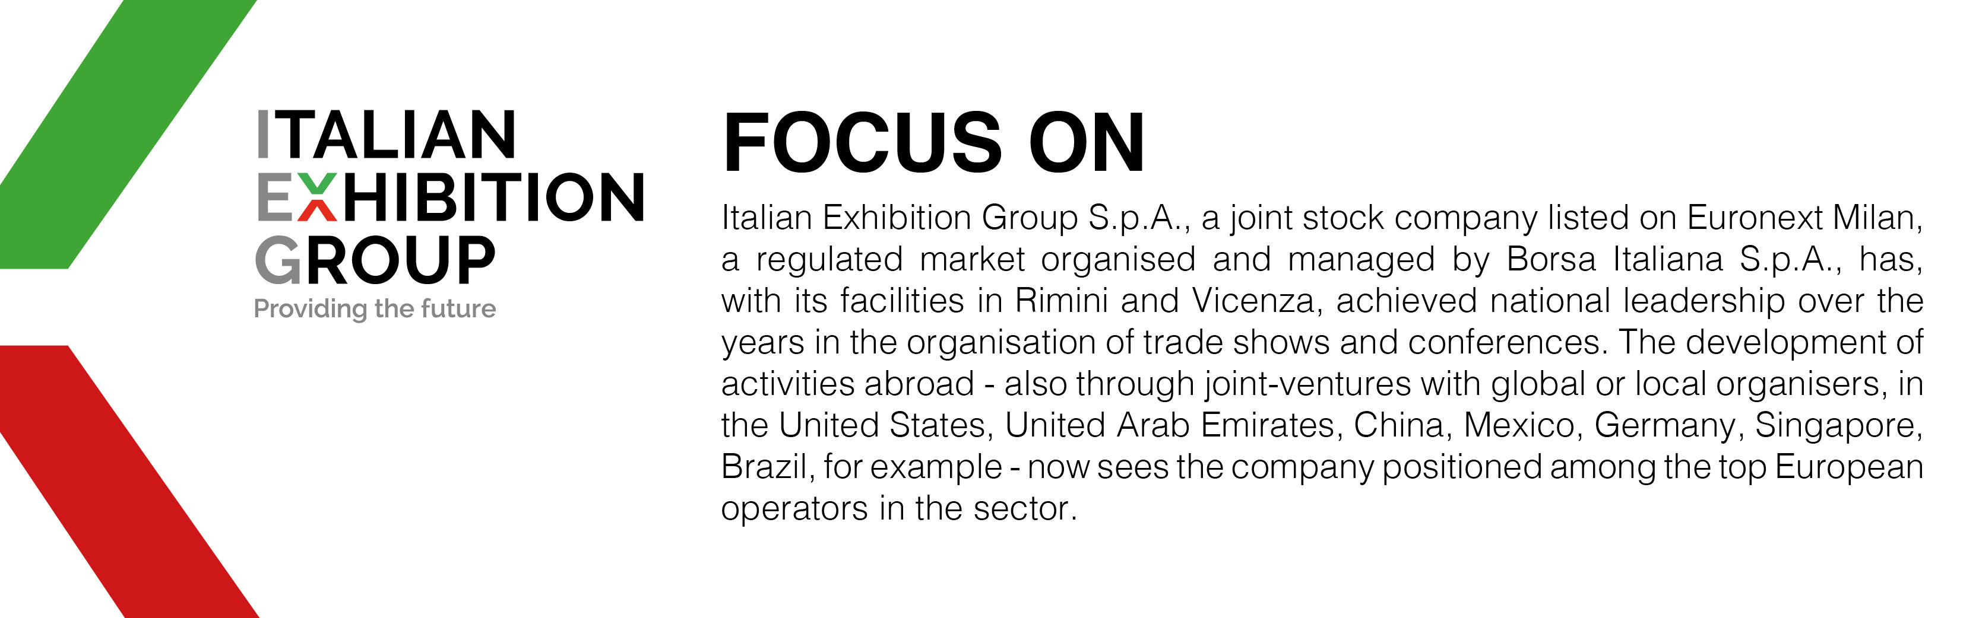

PRESS CONTACT ITALIAN EXHIBITION GROUP
head of corporate communication & media relation: Elisabetta Vitali |
press office manager: Marco Forcellini | press office specialist: Luca Paganin | media@iegexpo.it
MEDIA AGENCY RIMINIWELLNESS
Naper Multimedia| Zoe Perna | T. +39 02 97699600 | staff@napermultimedia.it

This press release contains forecast elements and estimates that reflect the management’s current opinions (“forward-looking statements”), particularly regarding future management performance, realization of investments, cash flow trends and the evolution of the financial structure. For their very nature, forward-looking statements have a component of risk and uncertainty, as they depend on the occurrence of future events. The effective results may differ (even significantly) from those announced, due to numerous factors, including, only by way of example: food service market and tourist flow trends in Italy, gold and jewellery market trends, green economy market trends; the evolution of raw material prices; general macroeconomic conditions; geopolitical factors and evolutions in the legislative framework. Moreover, the information contained in this release, does not claim to be complete, and has not been verified by independent third parties. Forecasts, estimates and objectives contained herein are based on the information available to the Company as at the date of this release.

